**Written 2.1**

**The Recommendation Report**

**Executive Summary**

Ever since the formation of DeepBlue Informatics (DBI) in 2018, it has seen rapid growth. Now, as the business is spreading globally it is important that customers from different countries can easily interact with the DBI’s website and to achieve that goal we have decided to setup an AI based translation tool that can covert website contents and documentations in several languages. This report assesses three different companies mainly based on two main requirements: their accuracy with machine translation, and the flexible software that can easily embedded in DBI’s system. By the end, this paper recommends collaborating with “Memsource” as that organization best fits with DBI’s requirements and future goals.

**Context**

Today, for globalizing the business it is important that customers from all over the world can understand and connect with the business websites and feel welcomed. The best way to achieve this customer satisfaction is by providing them with services in their native languages.

DBI’s business has spread worldwide with 700 hundred people working in 11 different time zones. Recently, the sales department implemented a WordPress website that provides background papers on deep learning, checklists for using DeepBlue’s systems, and documentation However, as we are gaining clients from different countries, language becomes a prominent barrier and since a major part of company’s website consists of background papers and documentations it is our priority to make the content simple and understandable

To solve this problem, we came up with an idea to install AI based tools which can make web content easier to interpret by translating the content of the website to comfort language of non-English speaking clients.

This AI based tools are accessed on three main criteria:

* Its accuracy with translating content.
* Time consumed installing, understanding, and setting up the tool.
* The tool will be an ideal fit if it can precisely translate the technical documents as well.

The best translation tool will be purchased to make the website more accessible for clients.

**Technical details**

For DBI, the topmost priority is to have systems which can give great user experience by making website content understandable to non – English speaking customers and can translate company’s technical documentations accurately without changing semantics of the original documents.

AI translators can be unreliable when it has to translate content without altering the semantics of it [1]. There are several different kinds of machine translations used by companies these days [2]. The different types of machine translations are Rule – based machine translation (RBMT), Statistical machine translation (SMT), and Neural machine translation (NMT) [2]. See the figure 1 to get an insight on how machine translation has progressed over years.

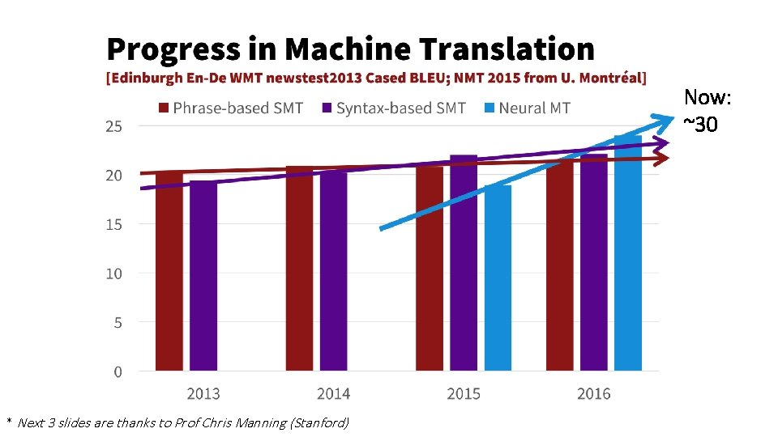In order to provide accurate translation without changing it’s meaning the AI tool must be able to understand which type of machine translation can be applied on specific content.

Figure 1 [3]

Progress in machine translation.

Memsource translate can effectively solve accuracy problem as, “it will automatically select the most suitable MT engine based on language pair, domain, and content type” [2]. Moreover, Memsource will provide customized machine translation engines so company can add their own technical terminologies [4] hence if we get custom made engine which uses all three machine translation methods we can get translation for general pages as well as technical documents. Memsource has leading machine translation engines like - Amazon translate, Microsoft translate, Google translate, DeepL many more - read to use; figure 2 shows how many different types of engines Memsource uses to provide accurate translations Additionally, their AI powered algorithm focuses on post editing also, the translations with high quality score are automatically excluded from post editing [4] hence it is less time consuming.Graphical user interface, chart, application

Figure 2. [5, p.12]

Breakdown of MT usage in Memsource by engine

Unbabel has customer centric approach towards translation [6]. It is more inclined towards providing translation for website’s customer service chat boxes. Unbabel uses human editors and advance artificial intelligence together to provide efficient, fast, and high-quality translations [6] figure 3 illustrates how Unbabel’s translation process works. Its machine translation software can, “Translate text word for word, or incorporate rule or statistic-based functions” [6] and then these translations are checked and edited by human translators this hybrid approach ensures preciseness of translation. Moreover, as customer can chat with customer service agent in their native tongue anytime they visit website, this will give a good user experience to them.

Figure 3 [7]

Unbabel’s translation process

Amazon translate seems like the most advanced AI translating tool. It is ranked as the” top machine translation provider in 2020” by Intento [8] . Amazon uses neural machine services to provide its translation services. It uses deep learning technologies to deliver accurate and more natural sounding translation [8]. Amazon claims that their translation services use large dataset which are studied by the machines over the time to produce accurate translation in wide range cases [8]. Moreover, it will be easy to integrate it with our company’s system as they have simple API’s (application programming interface) available for translating pre-existing texts as well real-time content. For instance, DBI’s existing background papers on deep learning and its technical documents and website can we converted using amazon’s “TextTranslation” API [9]. Additionally, as they also provide real time translation, we can introduce a customer service chat feature as well which can give clients good user experience.

The table1 below compares some of the services provided by each of the companies discussed above.



Table1: Comparing all the contenders [10], [11], [12] – [13]

|  |  |  |  |
| --- | --- | --- | --- |
|  | Memsource | Unbabel | Amazone Translate |
| Number of languages | 500+ | 90 | 75 |
| Customer centric | No | Yes | Yes |
| Type of MTs used | RBMT, SMT, NMT | NMT | NMT |
| Security | Yes | Yes | Yes |
| Cost efficient | Yes | Yes | No |

**Conclusion**

All the companies almost provide pretty accurate and high-quality translations. Please refer to the table1 in technical details section of this report to get idea about how company services differ from each other.

Memsource provides translation services, but it doesn’t have any of its own translation system. It basically analysis the content that it is to be translated and then uses other company’s translation tool accordingly. Moreover, it offer to provide customized translation engine for every unique document. So, using Memsource will be like collaborating with one company but getting services of multiple companies.

Unbabel’s customer centric approach and mixing AI translation and human translation to yield perfectly translated papers was very explicit, Using Unbabel’s services will help DBI’s client to interact with website customer service in real time and clear their doubts about the company services in their preferred languages.

Amazon translate provides both client and user centric services. It has better machine learning tools and large datasets [9] so it’s neural machine services automatically gets better as it has bunch of examples to learn translation from. Moreover, Amazon can translate pre-written documents and website easily because of its API system.

**Recommendation**

I would suggest collaborating with Memsource because it covers all criteria we required.

1. Unlike others it does not use one specify type of machine translation method. Rather it customizes its machine translation engine according to documents requirements. Therefore, its probability of inefficient translation is very unlikely to happen [2].
2. As it uses machine translation engines of different organizations it will be easy to set it up as we can design engine according to our needs [4].

Now, firstly, Memsource’s website doesn’t give much information on whether they have customer centric approach or not. So, we must inquire about what actions they can take to provide good customer service as we want to introduce a customer service “chat box” on the website. Secondly, we should take a demo of Memsource services if we are satisfied then we should go through the website content, papers, and technical documents and get Memsource to build a translation engine customed just for our company. Thirdly, we must decide which price plan suits our project style.

This will be best course of action because at the end we will be able to explain Memsource, that exactly what type of general services we will use and what needs to be customized.

**References**

1. Breda, “AI translators: The future of language learning”, oxfordhouse language courses [online]. Available: <https://oxfordhousebcn.com/en/artificial-intelligence-translators-the-future-of-language-learning/> [Accessed: March 4th, 2021]
2. Memsource, “Machines That Think: The Rise of Neural Machine Translation” [Online] October 12, 2021. Available: <https://www.memsource.com/blog/neural-machine-translation/> [Accessed: March 4th, 2021].
3. “Lesson 10 NLP Classification and Translation Last weeks” [online] <https://slidetodoc.com/lesson-10-nlp-classification-and-translation-last-weeks/> [Accessed: March 4th, 2021].
4. Memsource, “Memsource translate” [online] available: <https://www.memsource.com/features/memsource-translate/> [Accessed: March 4th, 2021].
5. J. Hofmeister, “Machine translation report Q4/2021” [online] available: <https://www.memsource.com/uploads/2022/02/08/mt_report_q4_2021_final.pdf> [Accessed: March 4th, 2021].
6. Unbabel, [online] available: <https://unbabel.com/industry/tech/> [Accessed: March 4th, 2021].
7. Unbabel, “Unbabel API documentation” [online] Avaliable: <https://developers.unbabel.com/v2/docs> [Accessed: March 4th, 2021].
8. AWS, “Amazone translate”, [online] available: <https://aws.amazon.com/translate/> [Accessed: March 4th, 2021].
9. AWS, “Amazon translate features”, [online] available: <https://aws.amazon.com/translate/details/#Batch_and_Real-Time_Translations> [Accessed: March 4th, 2021].
10. AWS, “Amazone Translate FAQs” [online] available: <https://aws.amazon.com/translate/faqs/> [Accessed: March 4th, 2021].
11. Unbabel, “language pairs we support”, [online] available: <https://unbabel.com/supported-languages/> [Accessed: March 4th, 2021].
12. Memsource, “Software and app localization”, [online] available: <https://www.memsource.com/solutions/software-app/> [Accessed: March 4th, 2021].
13. Wikipedia, “Unbabel” [Online] August 16th, 2022, Available: <https://en.wikipedia.org/wiki/Unbabel> [Accessed: March 4th, 2021].